**Model view in Power BI**

**Introduction**

The **Model view** in Power BI is essential to creating and managing data models within your reports. In this reading, you’ll explore the main UI elements within the **Model view** in Power BI.

**Model view overview**

The **Model view** visually represents all data tables, relationships, and columns. You can use these visuals to shape and structure your data. The **Model view** is especially crucial when a data model contains complex relationships between its tables.

**Model view elements**

The **Model view** can be accessed by selecting the **model** icon on the left sidebar of Power BI desktop. The **Model view** contains the following UI elements:

* **Diagram view (canvas)**
* **Data pane**
* **Properties pane**
* **Home ribbon**

Each of these elements is explored in detail below.

**Diagram view (Canvas)**

The **Diagram view** presents a visual overview of your data model. You can use it to visualize important elements of your data model, like the data tables, fields, and relationships. These elements are explored in more detail below.

**Data tables**

Data tables represent the raw data you import or connect to Power BI. The tables contain fields (columns) and rows of data. In the **Model view**, you can view a list of all your data tables (both imported and calculated). You can expand (collapse) the data table to view (hide) the fields within it.

The small eye icon on the top right of the table diagram allows you to hide the table from the Power BI desktop report view.

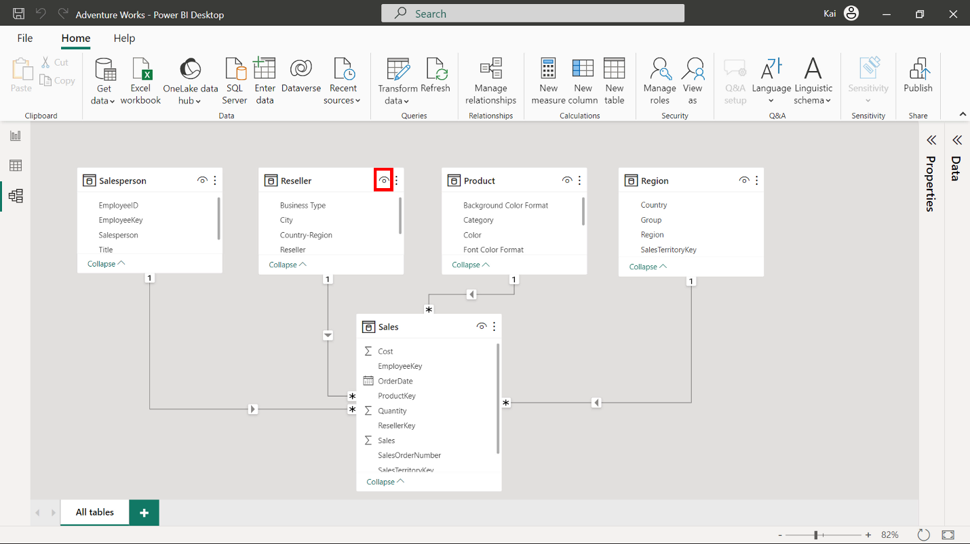

You can access more options by selecting the ellipses beside the eye icon of the table diagram.

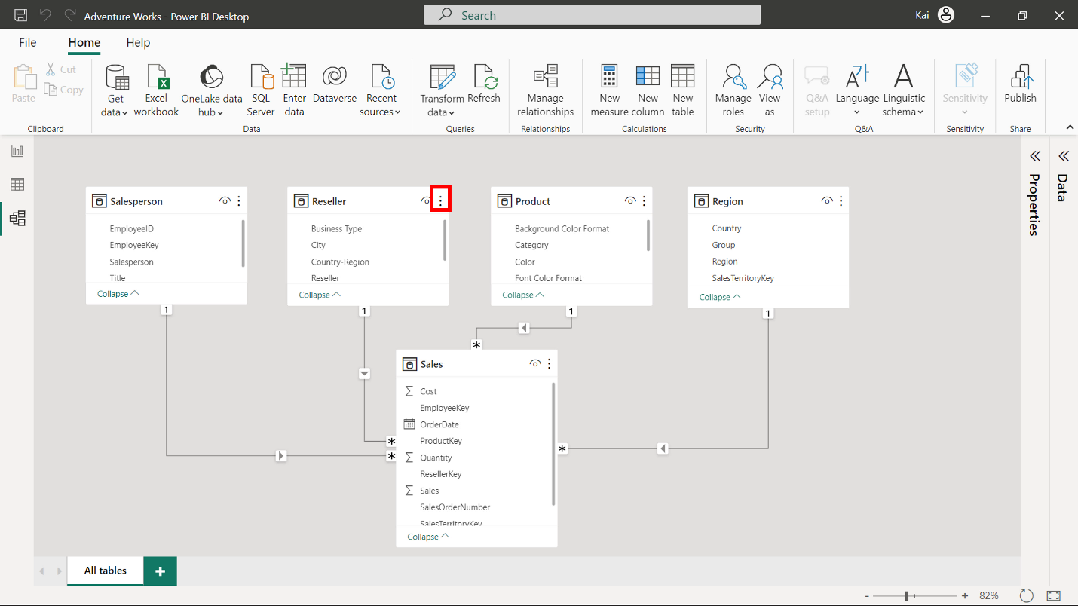

**Fields**

Fields are columns within your data tables. In the **Model view**, these fields are listed under their respective tables. All calculations (calculated columns and measures) also appear as fields in the data tables.

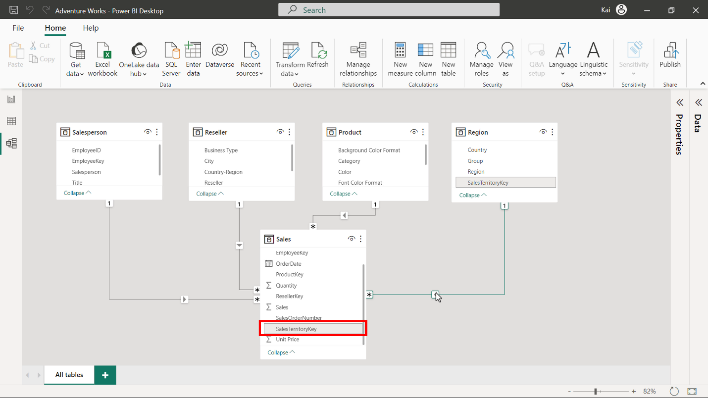

**Relationships**

One of the key features of the **Model view** is establishing and managing relationships between tables. You can create and configure relationships between tables based on common key fields.

(Note that the points below may contain concepts you’re not currently familiar with. Don’t worry; you’ll discover more about these concepts and relationships in the coming lessons.)

Tables are related through a relationship line (connector line). When you hover over the connector line, it highlights the fields used to establish the relationship. The arrow on the connector line indicates the direction of the relationship (cross-filter direction).

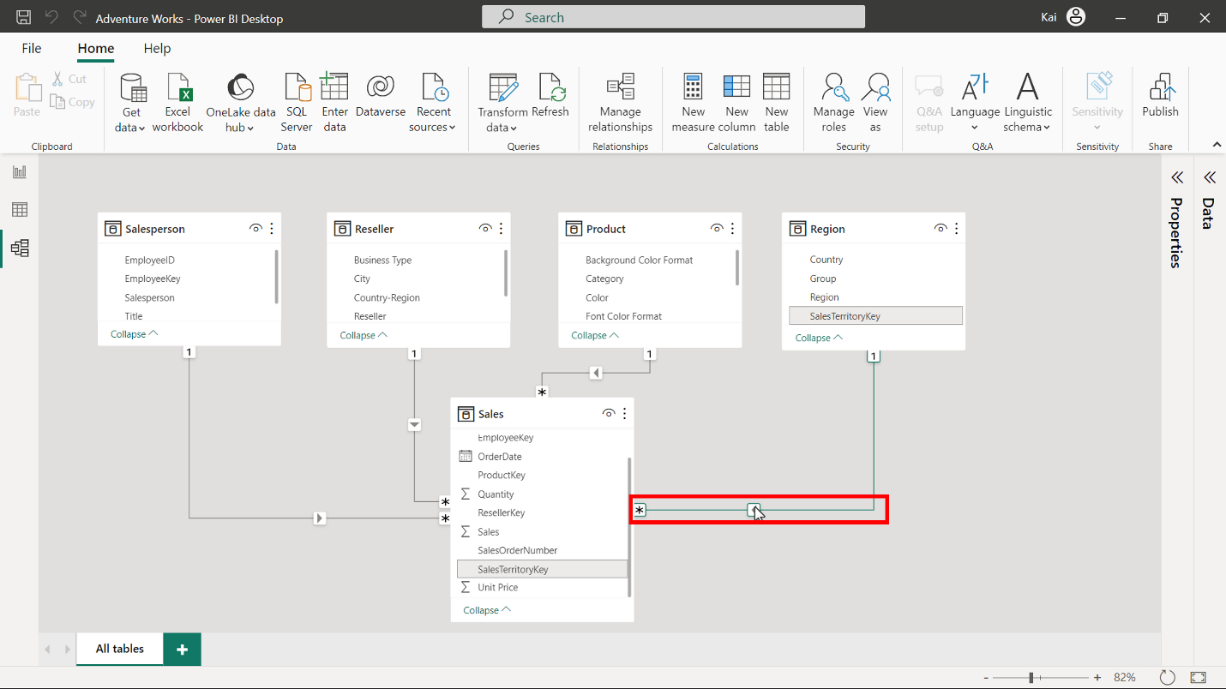

The **connector line** connects two tables. The **1** icon represents the **one** side of the relationship, while the **\*** icon indicates the **many** side of the relationship.

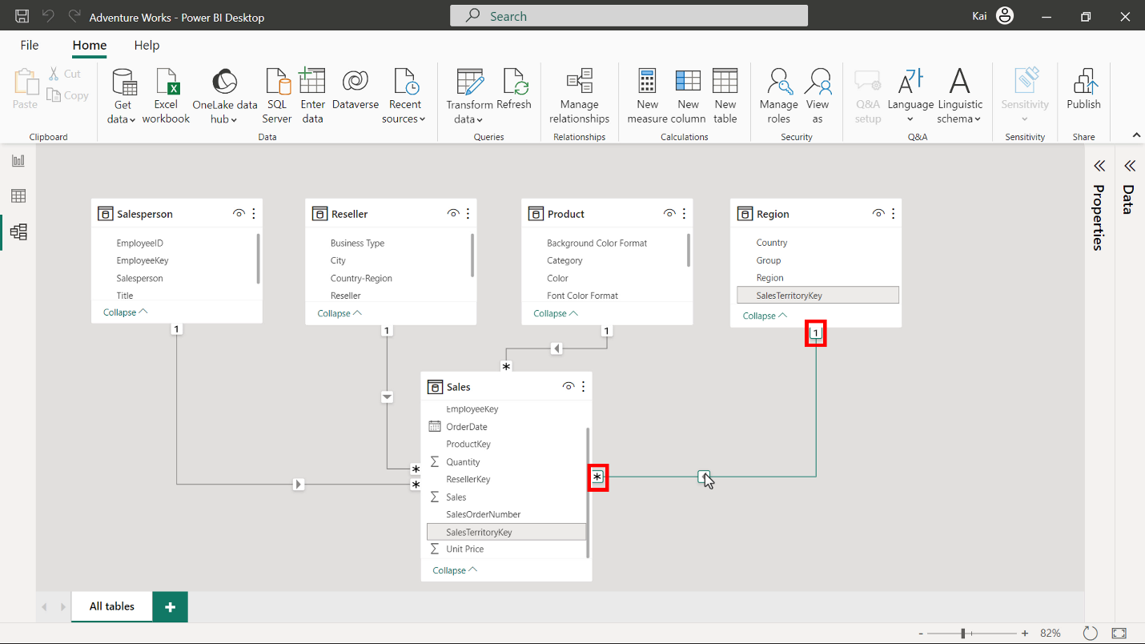

You can select and double-click the **connector line** to open the **Edit relationship** window. You can use this window to edit or configure the relationships between your data tables.

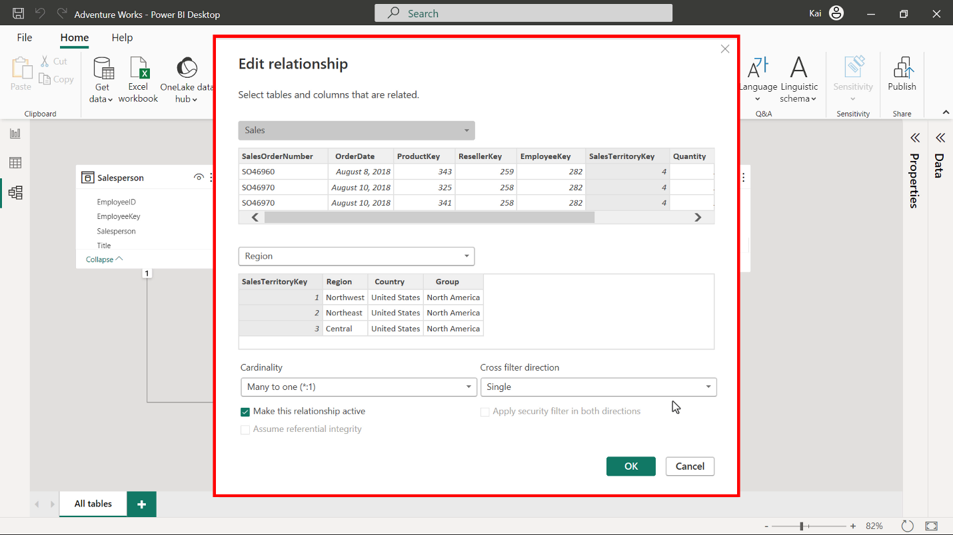

When you load multiple tables into your data model, Power BI automatically detects their relationship based on the common key field.

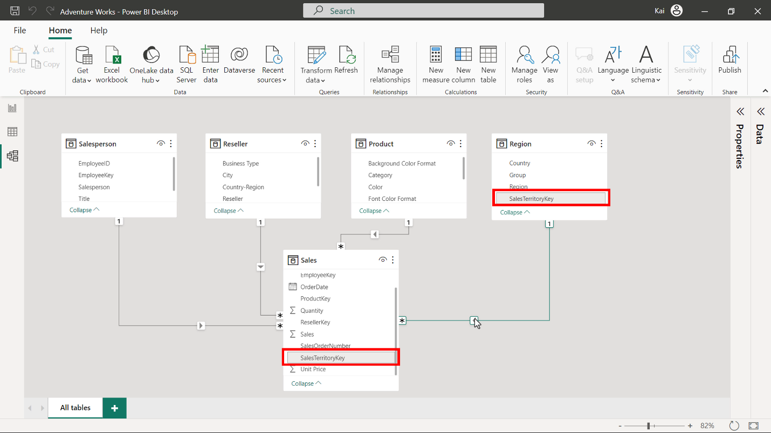

**Data Pane**

The **Data pane** is the common element in all three views of Power BI desktop (**Report view**, **Data view**, and **Model view**).

The **Data pane** lists all data tables and fields within the tables. All types of calculated tables, columns, and measures you will create are listed under the **Data pane**. If your data model contains many tables, you can use the search bar to locate a specific data table.

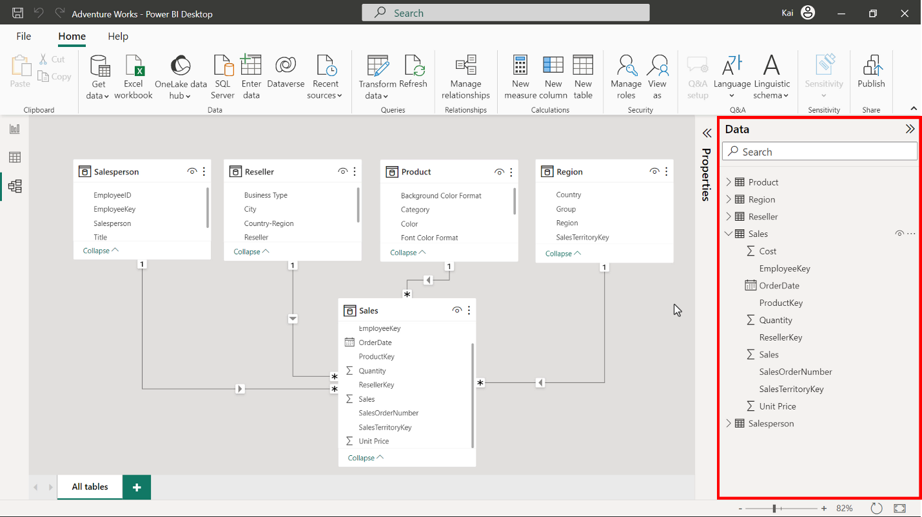

You can also expand or collapse the data pane by selecting the double arrow.

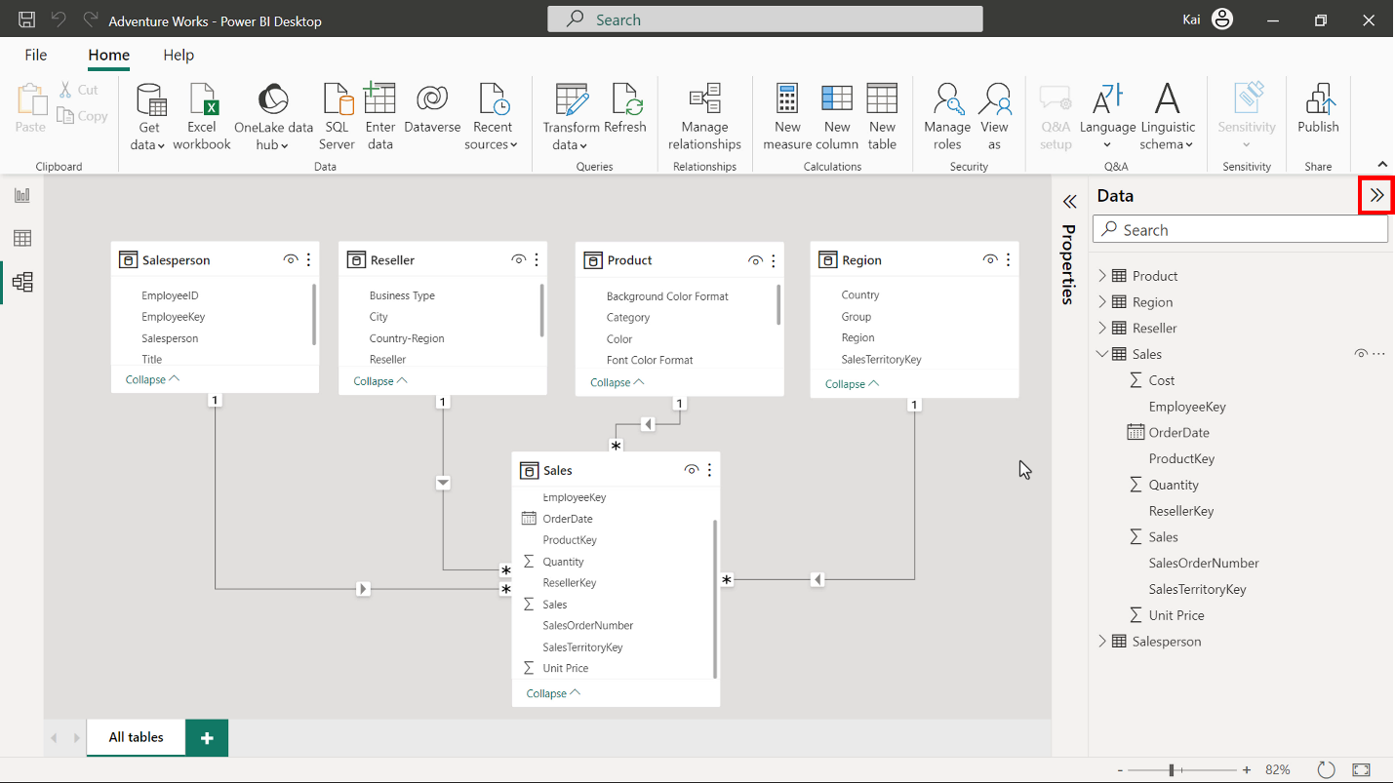

**Properties pane**

You can use the **Properties** pane to edit and configure table and column properties within your data model. The pane has two sets of properties: **General** and **Advanced**. You can use these properties to rename your table and columns, add descriptions, and configure other table and column properties.

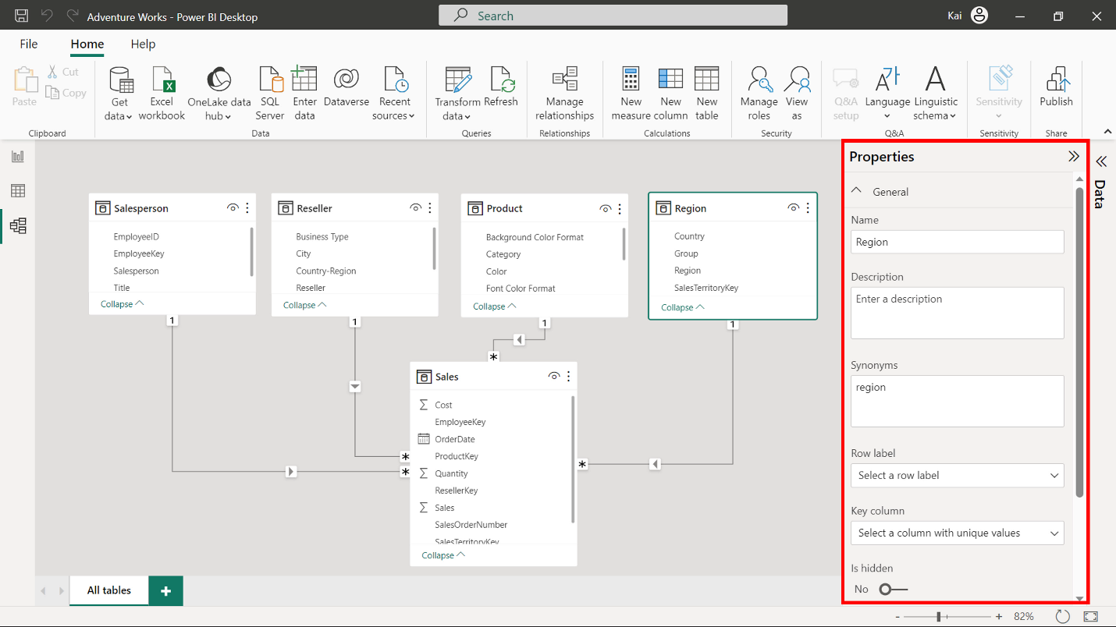

**Home ribbon**

The **Home ribbon** of the **Model view** offers a range of functions to shape and structure your data before preparing it for reports and visualizations. Below is a list of the various groups of functions available in the **Home ribbon**.

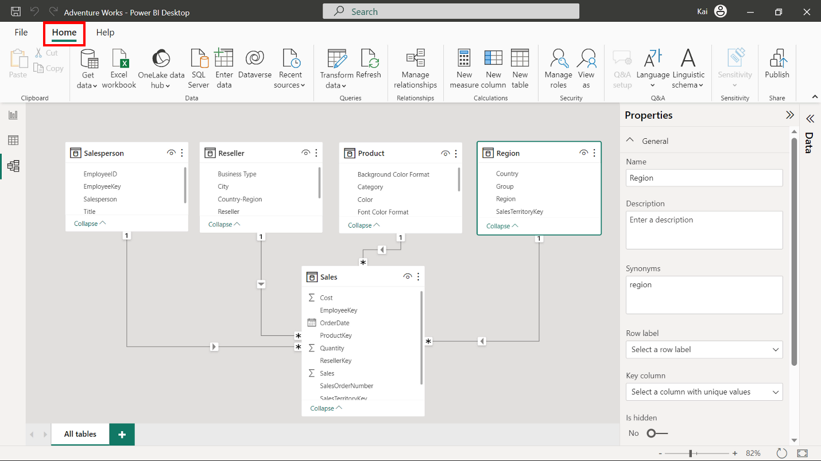

**Feature:** Data

**Explanation:** The **Home** tab’s **Data group** is like the **Report view** and **Data view**. It offers data connectivity options for Power BI.

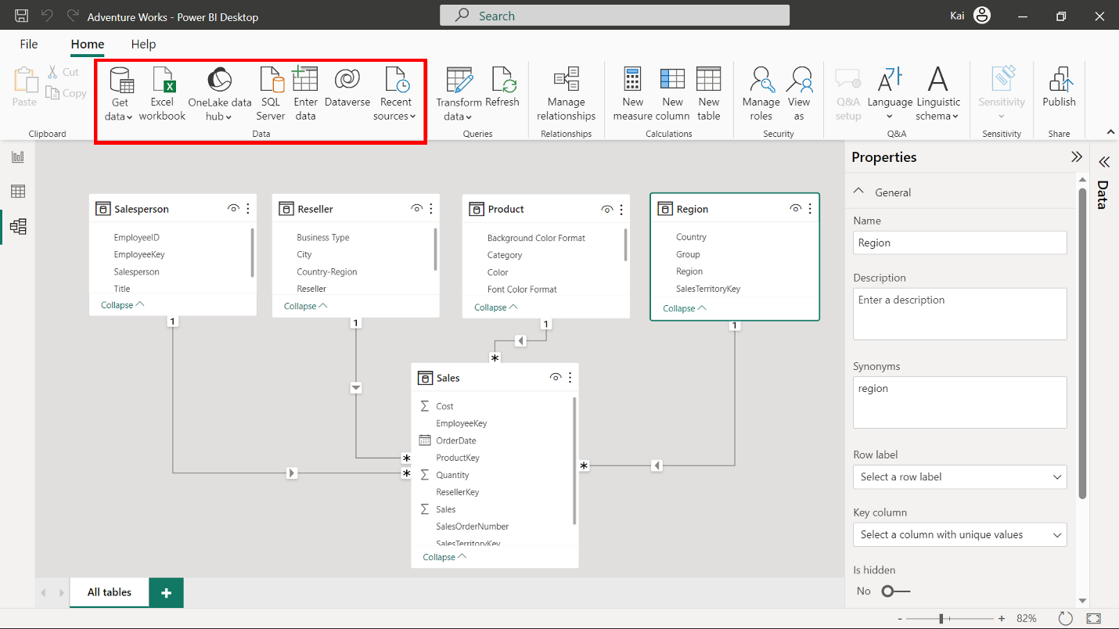

**Feature:** Queries

**Explanation:** This section contains two elements:

* **Transform data** redirects you to the Power Query editor, where you can perform necessary transformations on your data.
* **Refresh** is used for data refresh. This is useful for when you change a dataset.

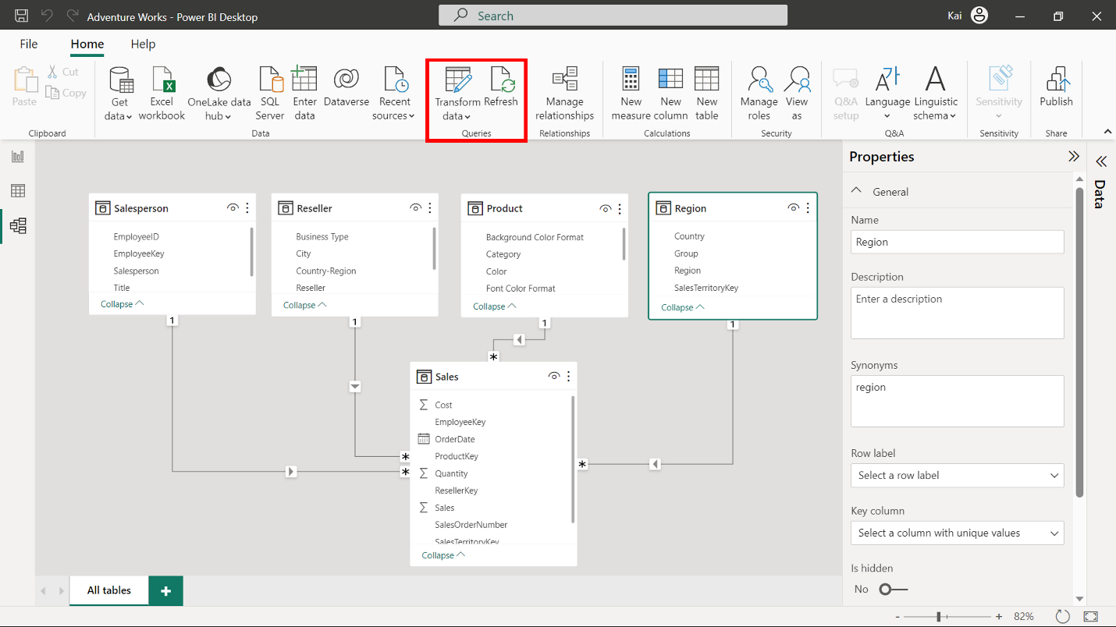

**Feature:** Manage Relationships

**Explanation:** This is the only element in the relationships group that you can use to establish new relationships between data tables and edit existing relationships.

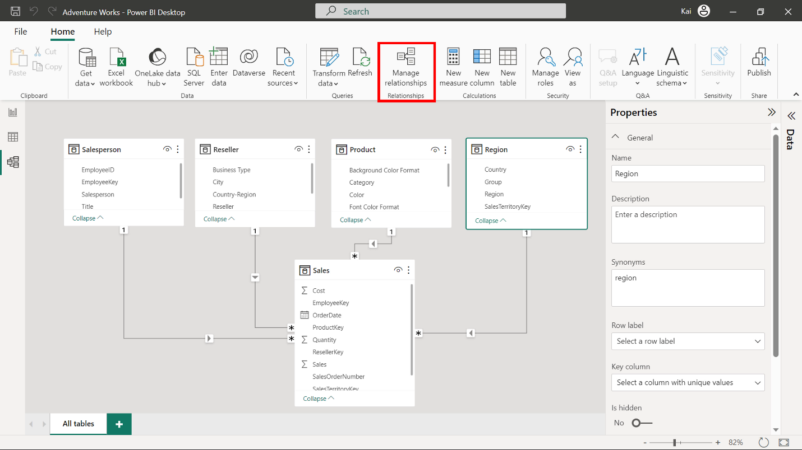

**Feature:** Calculations

**Explanation:** You can use this group to add new custom calculations to your data model, like creating new tables, columns, and measures. These calculations are created using a Power BI language called Data Analysis Expressions (DAX). These calculations enable you to enhance your data analytic capabilities and uncover the information hidden in your data.

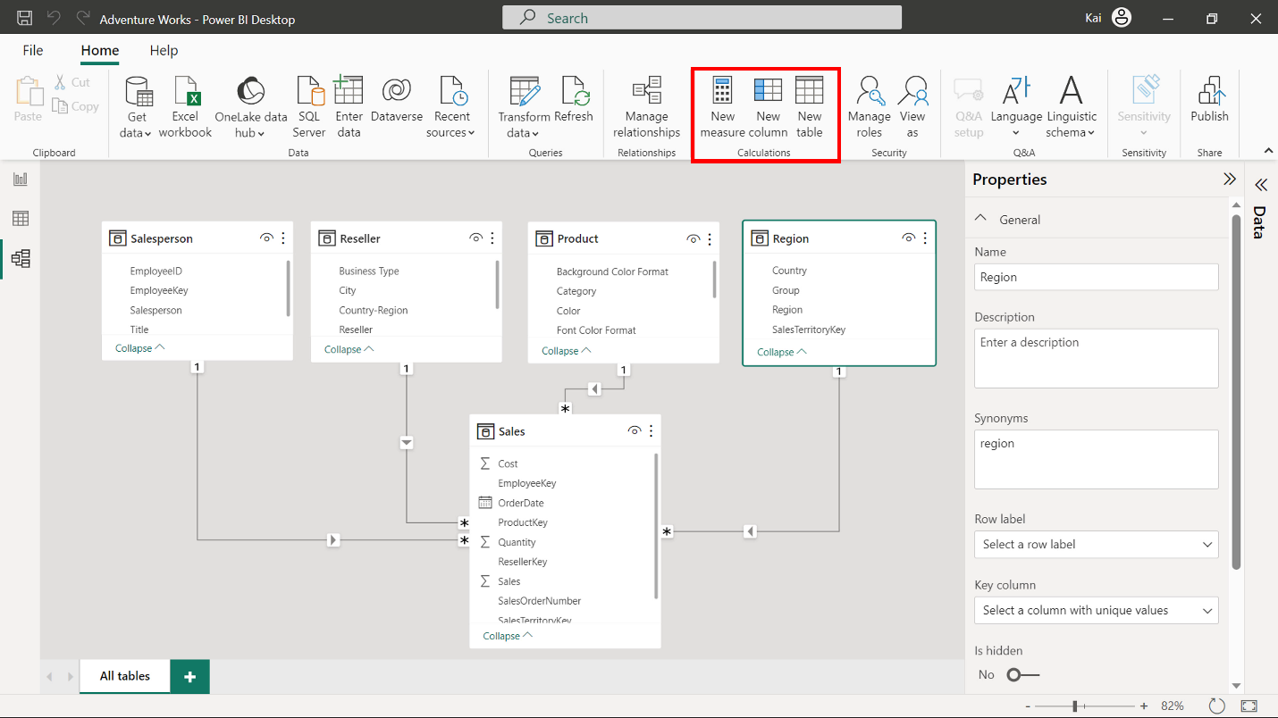

**Feature:** Security

**Explanation:** You can use this feature to define roles and rules within Power BI desktop to restrict data access for certain users. This provides you with better security for your data.

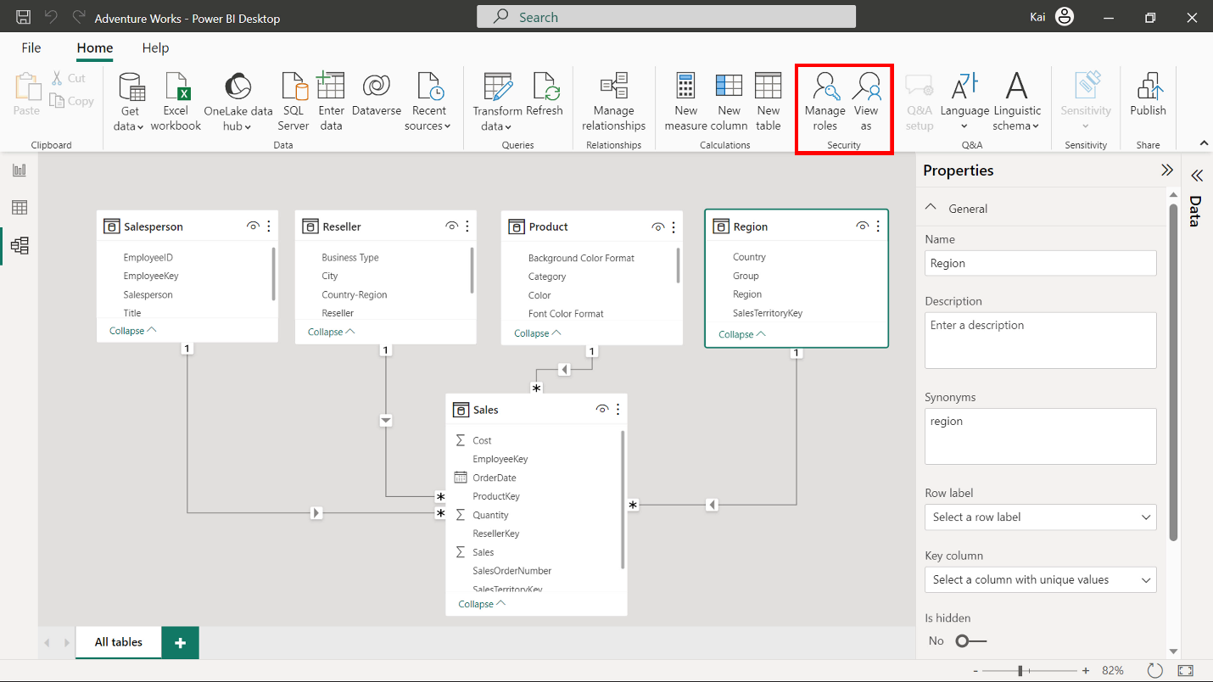

**Feature:** Q&A

**Explanation:** Q&A (Question and Answer) is a powerful natural language query and visualization tool that you can use to interact with data more intuitively.

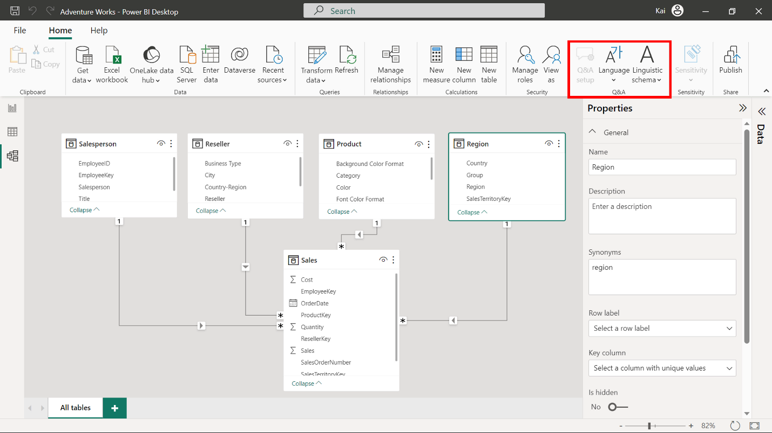

**Feature:** Share

**Explanation:** You can use this element to share your report with other users within your team for effective collaboration.

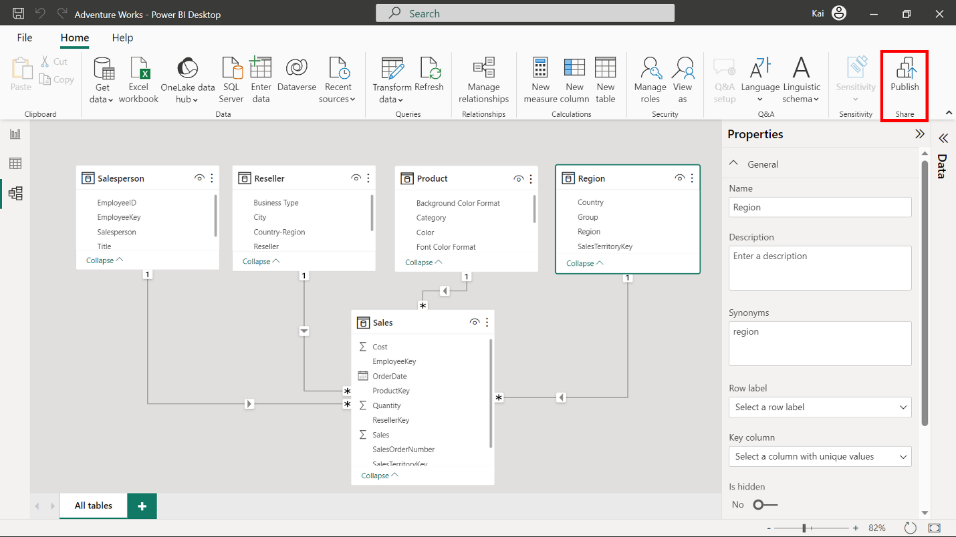

**Conclusion**

Develop familiarity with the **Model view** UI and its various components in Power BI. This will benefit you when you begin exploring the advanced concepts in data modeling, schema design, and DAX during your Power BI journey.